# User Manual for Admin Portal

Table of Contents

User Manual for Admin Portal 1

Analytics Dashboard 2

Order Management 2

Factory Process Breadcrumb 3

View Orders 3

Admin Profile 4

Edit Profile 4

Staff Management 4

Edit/Delete Staff 4

Add Staff 5

Catalogue 5

Add Product 6

Add Design 6

Add Fabric 6

Add Colour 6

Add Collection 7

Edit 7

Promo Code 8

Terminologies 8

Add Promo Code 8

Superuser Management 9

Edit Order 9

## Analytics Dashboard

The analytics dashboard function only accessible by the manager. The dashboard provides insights from Google Analytics which have been configured to track the number of visits to the site, the viewing of each product, etc.

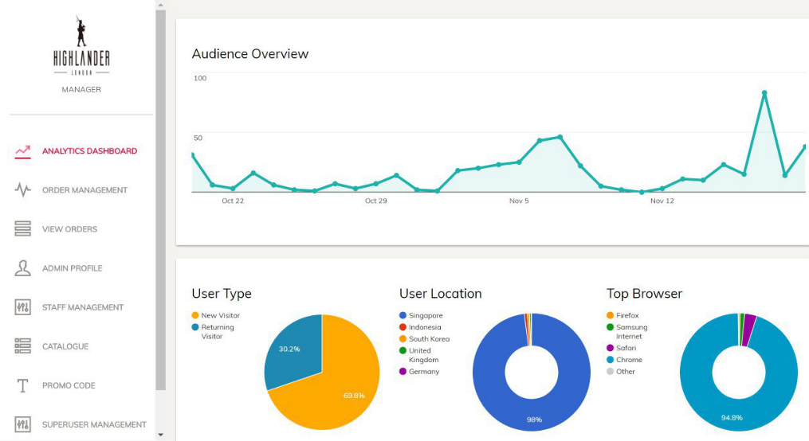

## Order Management

The order management tab is accessible by both the manager and the factory quality checker. Orders have been organised into “All”, “Payment Received”, “In Production”, “Packaging”, “Pending for Shipment”, “Shipped” and “Completed”. Quality checkers responsible for their respective steps, can filter to look at the orders under their care.

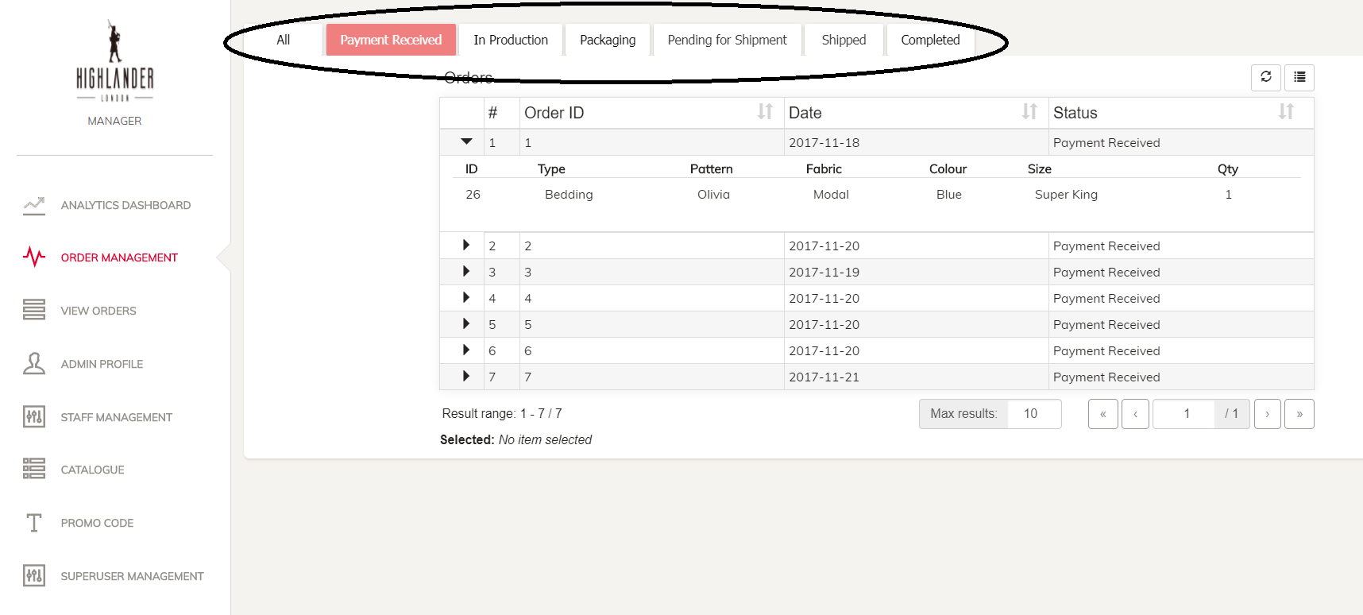

### Factory Process Breadcrumb

To change the status of the product, you can click on the respective row and a new page like below will appear. Factory QC can click on “Next Process” to move the order forward or “Previous Process” for the order to go backward. Do not that status changes will be logged in the database.

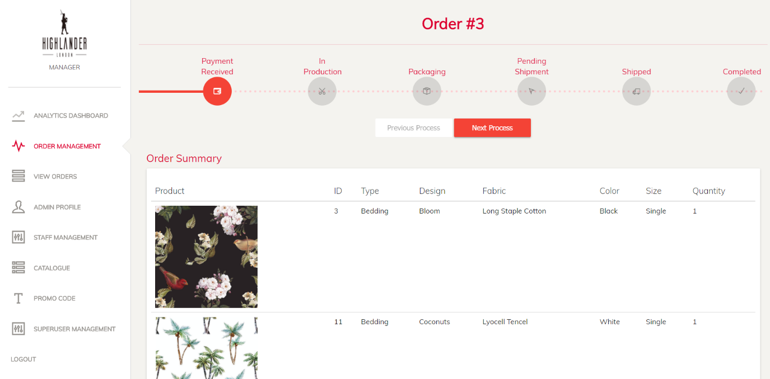

## View Orders

The View Orders function is only accessible by the manager and the factory staff. This function allows the respective staff to look at the details of the order under different stages. Production staff can refer to the “In Production” tab and click on the arrow down to reveal the details of the order.

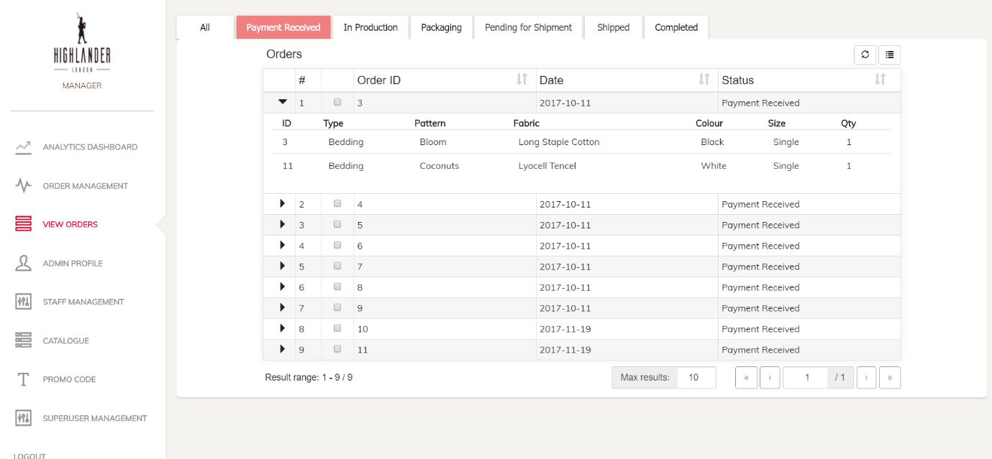

## Admin Profile

The Admin Profile function is accessible by all roles where they can edit their own details and password. However, their changes may be overwritten by the super user using the Staff Management function.

### Edit Profile

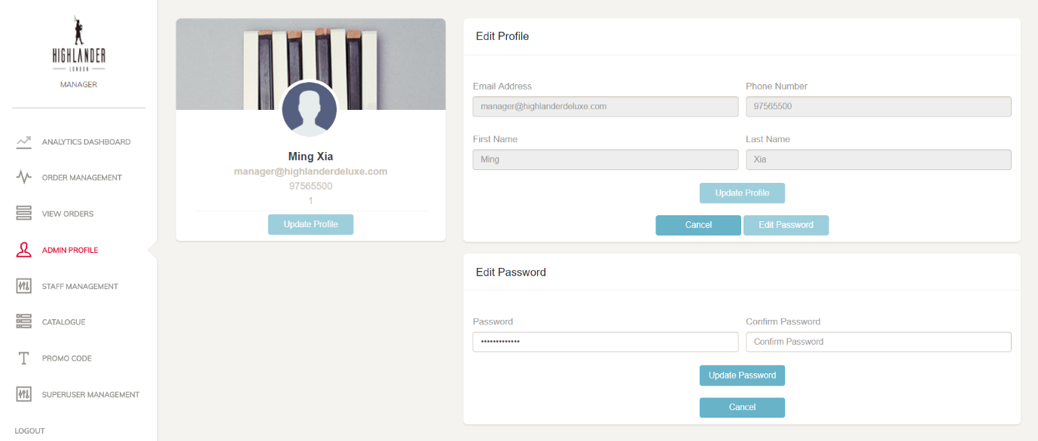

## Staff Management

The staff management accessible by only the manager. The staffs in the list can be edited by clicking on the “Edit” button or deleted by clicking the “Delete” button.

### Edit/Delete Staff

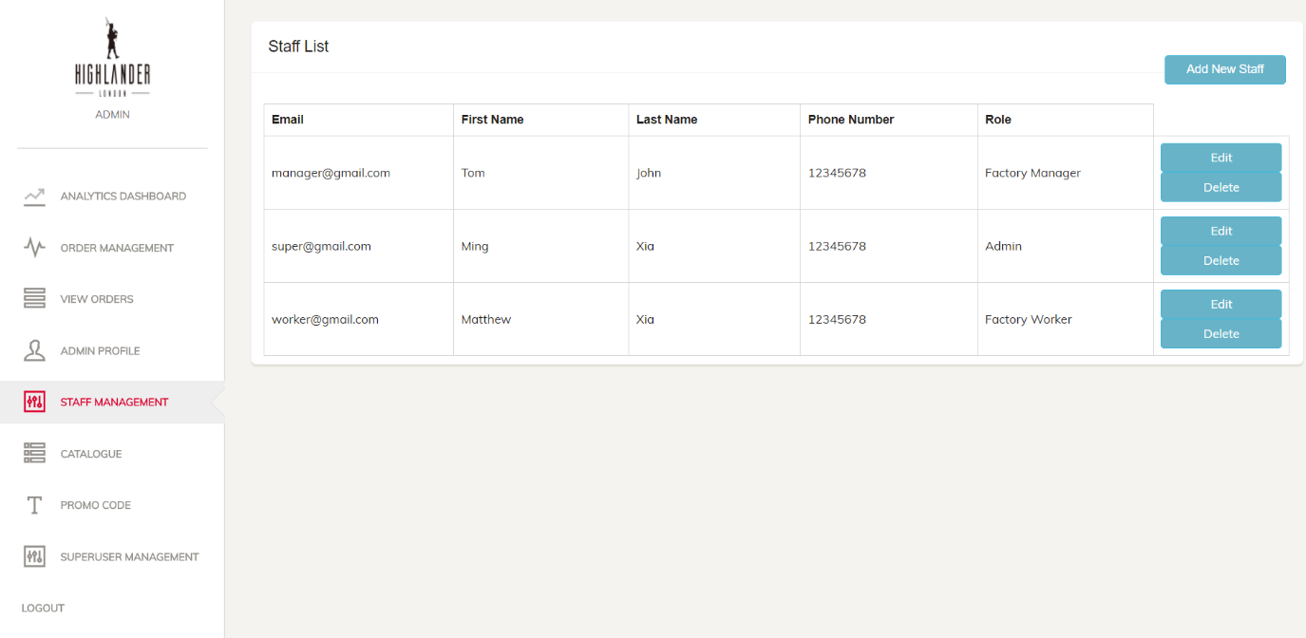

### Add Staff

New staffs can also be added by clicking on the “Add New Staff” button. For the roles, manager is a super user that has access to all the functions, Factory QC have access to the order management function which allows them to move the status of the order forward or backward. The Factory Staff have access to the View Orders function which allows them to see the details of the product to be produced.

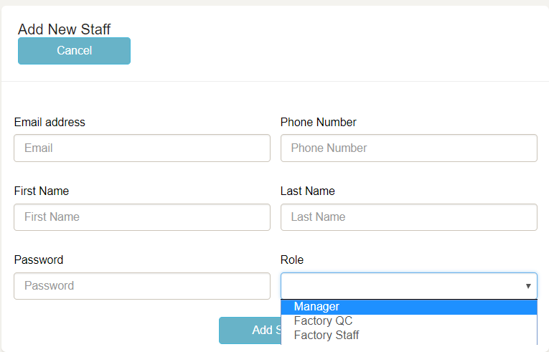

## Catalogue

The product catalogue is only accessible by the manager where the “Product” tab reveals the list of all existing products. Different Tabs will reveal their respective “Add” buttons to add new “Product”, “Design”, “Fabric”, “Colour” and “Collection”.

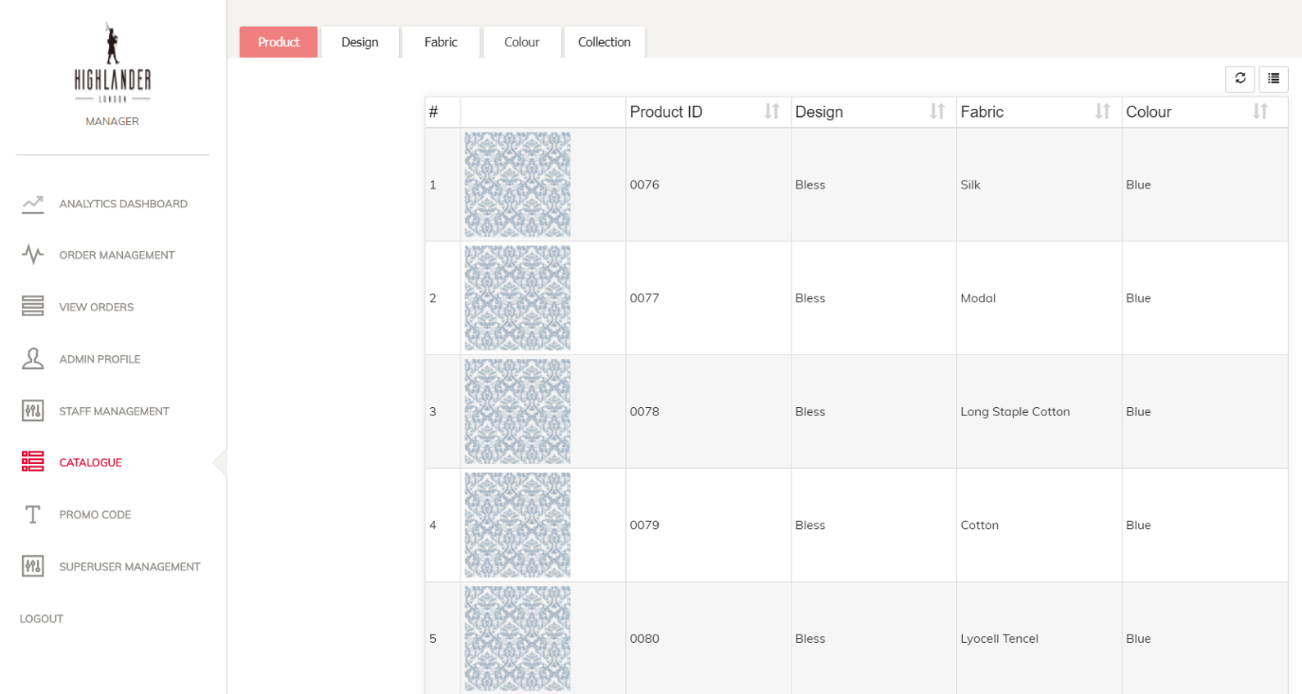

### Add Product

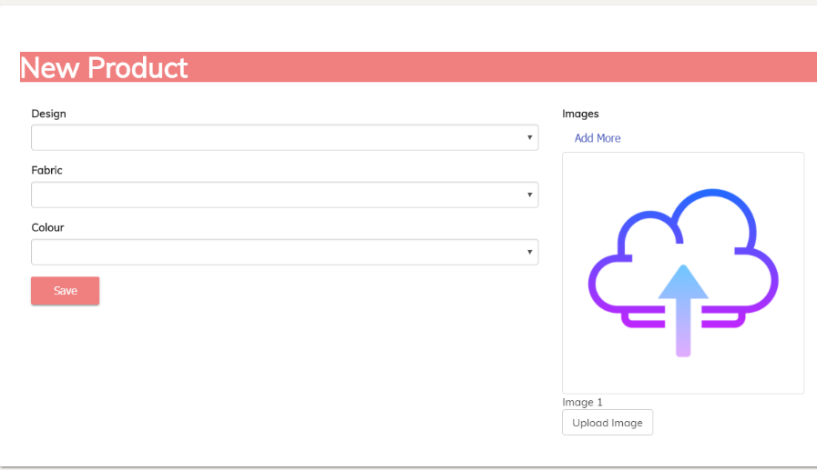

### Add Design

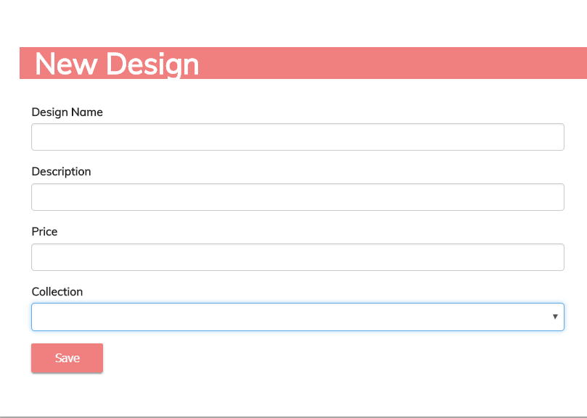

### Add Fabric

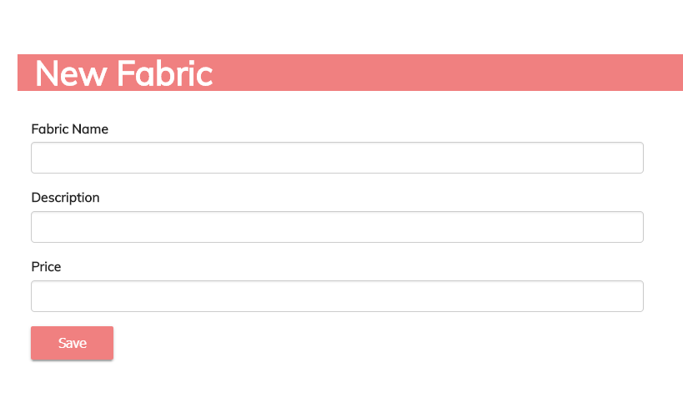

### Add Colour

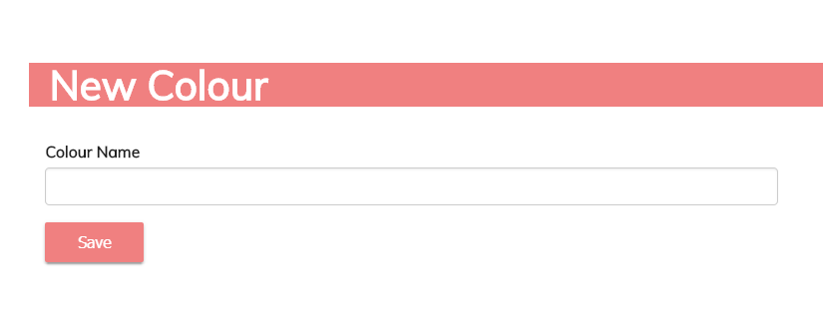

### Add Collection

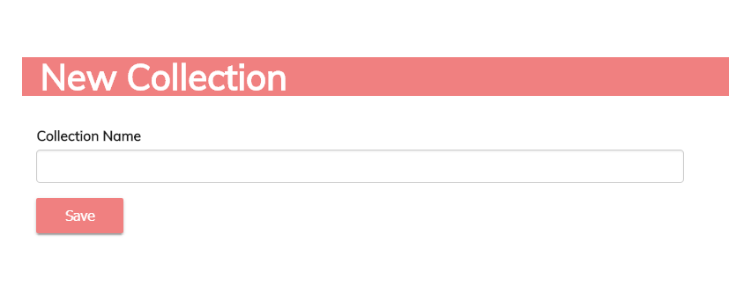

### Edit

Clicking on the respective tables and items will bring you to the details page where editing can be done by clicking on the “Edit” button.

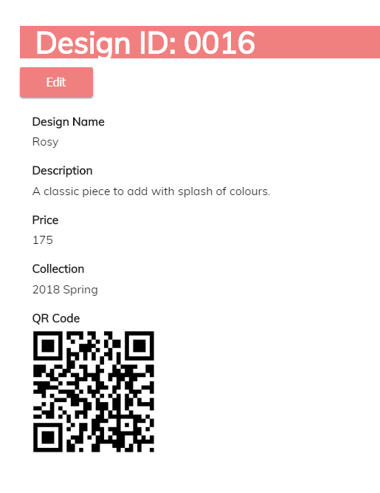

## Promo Code

The promo code function is only accessible by the manager. Clicking on the promo code tab will reveal a list of existing promo codes where user can choose to delete them.

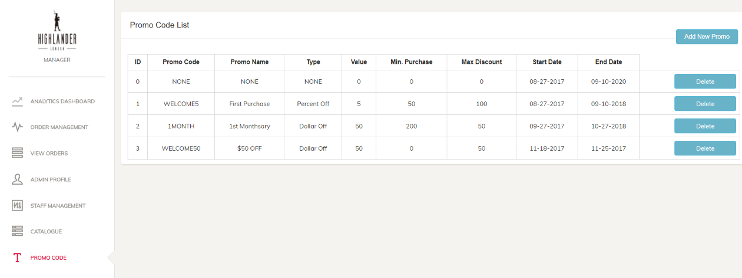

### Terminologies

Promo Code: The code that customer will enter

Promo Name: Name of promotion for manager’s own reference

Type: Percent Off – for % discount

Dollar Off – for $ discount

Value: Value - 5 & Type - Percent Off -> 5% discount

Value – 5 & Type - Dollar Off -> $5 discount

Min. Purchase: Minimum spending amount for the promo code to by applied

Max. Discount: Discount value capped at

### Add Promo Code

Click on the “Add New Promo” button to enter the details of a new promo code to be created.

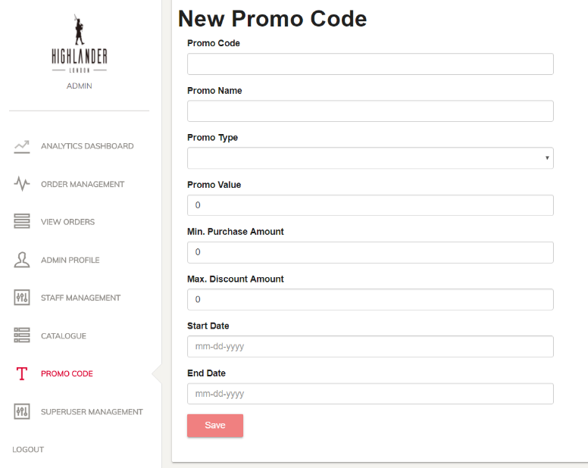

## Superuser Management

The Superuser Management is only accessible by the manager where he can view and edit all the details on the orders in case of any discrepancy. This function caters to situations when customers call in to change any details of their orders.

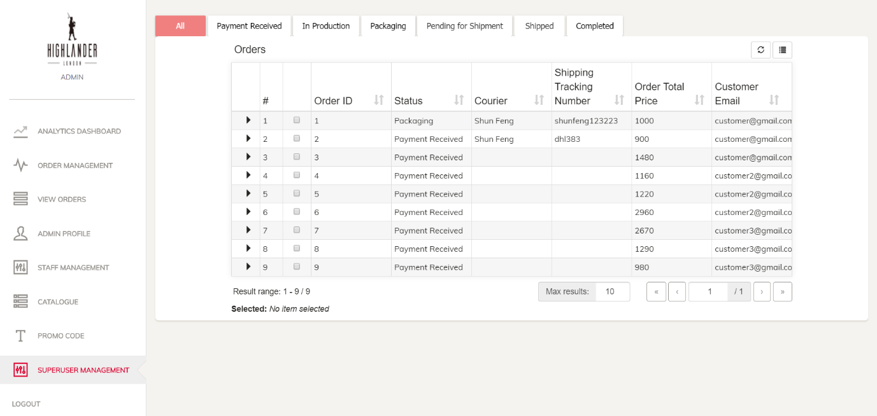

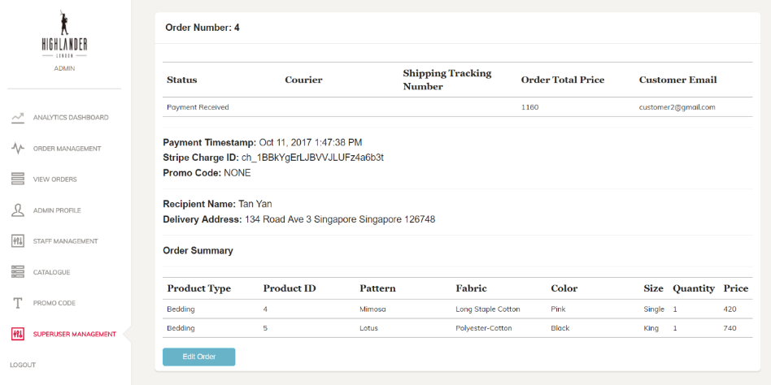

### Edit Order

